International Nuclear Sciences and Technologies Conferences-2022

Manuscript Submission Instructions for JRNC

Each manuscript must be electronically submitted by the corresponding author using the JRNC Editorial Management (EM) system.

Deadline for manuscript submission is 16 January 2023

Please carefully follow the instructions given below.

1. Open JRNC EM system for online submission: http://www.editorialmanager.com/jrnc/

2. If you are a user already, log in as “Author”. If you are not yet a user, please register first, then log in as an “Author”.

3. Click on “Submit New Manuscript”.
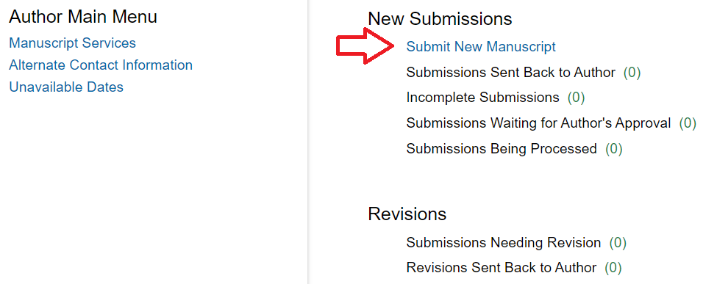

4. (Very Important) From the drop down menu, select article type “S.I. : International Nuclear Sciences and Technologies Conference (INSTEC-2022):

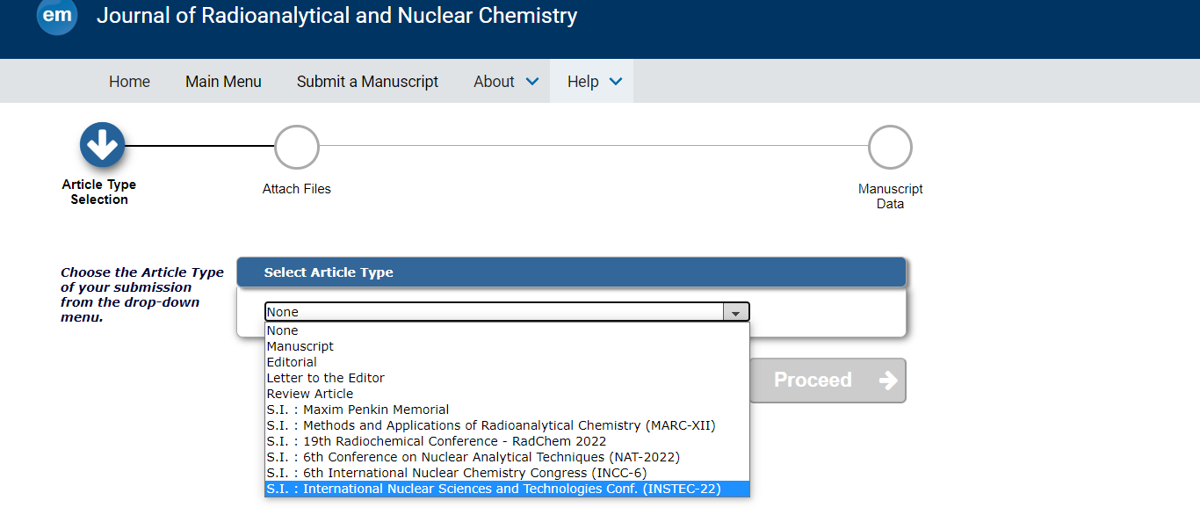

5. Attach your manuscript in prepared using Microsoft Word software in doc or docx format. Do not upload in Pdf format!
Submission of manuscripts in LaTeX is also possible. For the moment, we cannot offer you template, please follow the instructions.
The topic of the manuscript must fall within the aims and scope of JRNC.

6. Your manuscript should be prepared based on our manuscript template file. The template file in doc version could be downloaded from the JRNC home page at
https://www.springer.com/journal/10967 under "Journal updates" section

These are some typical mistakes we see very often:
- several authors do not use our template
- the manuscripts should be uploaded in doc/docx and not in pdf version! Submission of manuscripts in LaTeX is also possible. For the moment, we cannot offer you template, please follow the instructions.
- some abstracts are too long (maximum 50-100 words). Introductory remarks should be avoided!
- tables should be submitted in editable format (doc/docx) and NOT as figures!
- some figures are not good enough to reproduce. Figures should be submitted in tiff/jpeg format with 300 dpi resolution (min. 1200x1200 pixels).
- references are not well formatted. See our template at Instructions for Authors section (EndNote-style for citations)
- we are fine with non-English references cited in the manuscripts, but according to our policy non-English references can be cited by the authors only if 1) the named reference has at least an abstract in English AND 2) it has a DOI number too.
Please also follow the nomenclature as described in:
https://link.springer.com/article/10.1007/s10967-017-5693-0

8. Follow rest of the instructions and submit your manuscript.

- Extended abstracts (manuscripts shorter than 200 lines and fewer than 10 references) will not be accepted for publication and will be returned to the corresponding author without review.

- All manuscripts are automatically checked for plagiarism including self-plagiarism; if the manuscript contains several long word-by-word quotations, even one table or graph, etc. from copyrighted publications (including authors’ own papers), it will be returned to the corresponding author without review.

